Camping Confirmation & Members list

FORMULA SAE ITALY, FORMULA ELECTRIC ITALY & FORMULA DRIVERLESS 2019
Please send this form filled in and signed within April 05, 2019 to: c.rossi@anfia.it

The undersigned, representing the Team _______________________________________ Car n. _________

University Name _________________________________________________________________________

(all details required)
Title | Birth date
Surname
Name

The invoice of the payment will be issued to
University/Team/Company
Department
Address
Post code |  | City
Country
Phone |  |  | Fax
E-mail
VAT Number (EC Countries only)
Cod. Identificativo (Italy only)
Cod. Fiscale (Italy only)

Confirms that the above mentioned team will camp in the area expressly dedicated for 2019 Formula SAE Italy & Formula Electric Italy event.60
CAMPING ACCOMODATION FEE for 6 days stay (from July 23 to 29, 2019) = 61,00€/person + 22% VAT = 74,42€

N. of persons ________ x 61,00 or 74,42€ = Total __________________
Please specify:
N. of small tents (3x3m)__________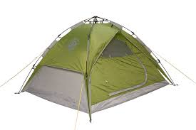 N. of big tents (6x6m)__________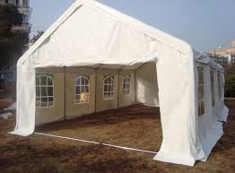
N. of motor caravans_____________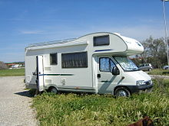

PAYMENT METHOD
The overall amount + all bank transfer charges must be paid by bank transfer to ANFIA Service Srl – Bank name: Cassa di Risparmio di Bra – Turin Branch - Italy – IBAN n.: IT04G0609501001000000003046 – Swift code: BPMOIT22 (Please write the team’s name and the university’s name on the bank document. Payment must be received in full. ALL bank transfer charges must be covered by the payer.)

Date _______________________ Signature __________________________________________________________

Camping Confirmation & Members list
FORMULA SAE ITALY, FORMULA ELECTRIC ITALY & FORMULA DRIVERLESS 2019

Team Name and Car n.

University Name
List of the Team Members
Name | Surname | Passport/IC n.
1.
2.
3.
4.
5.
6.
7.
8.
9.
10.
11.
12.
13.
14.
15.
16.
17.
18.

Camping Confirmation & Members list
FORMULA SAE ITALY, FORMULA ELECTRIC ITALY & FORMULA DRIVERLESS 2019

Team Name and Car n.

University Name
List of the Team Members
Name |  | Surname |  | Passport/IC n.
19.
20.
21.
22.
23.
24.
25.
26.
27.
28.
29.
30.
31.
32.
33.
34.
35.
36.

Camping Confirmation & Members list
FORMULA SAE ITALY, FORMULA ELECTRIC ITALY & FORMULA DRIVERLESS 2019
Team Name and Car n.

University Name
List of the Team Members
Name |  | Surname |  | Passport/IC n.
37.
38.
39.
40.
41.
42.
43.
44.
45.
46.
47.
48.
49.
50.
51.
52.
53.
54.

